8. Layer 2 VLAN Security
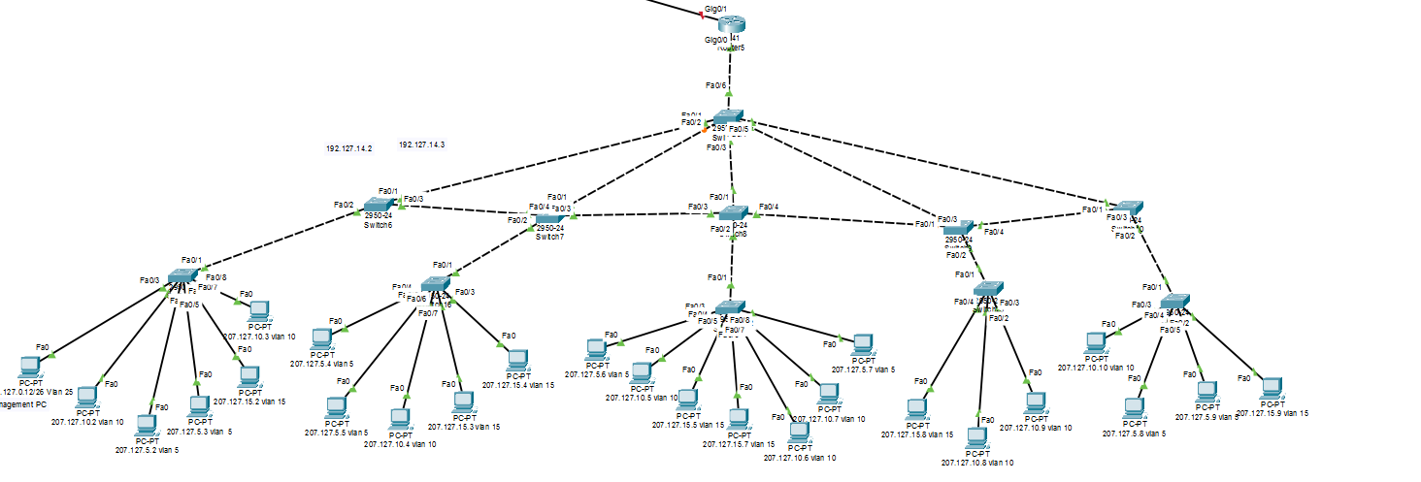
Assign VLANs to Central switch :
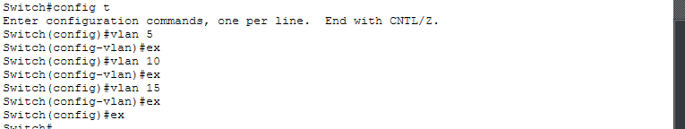
Showing all vlan :
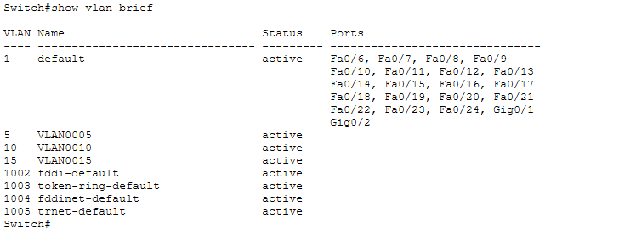

Assigning Central switch by VLANs number for switch to switch connection with mode trunk :
Command :
Config t
int fa0/1
switchport mode trunk
switchport trunk native vlan 15
no shut
ex

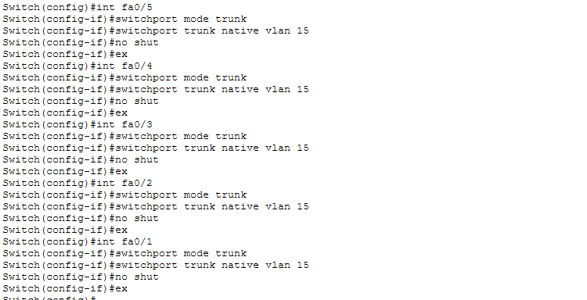

To display trunking interfaces :
Command : show interfaces trunk
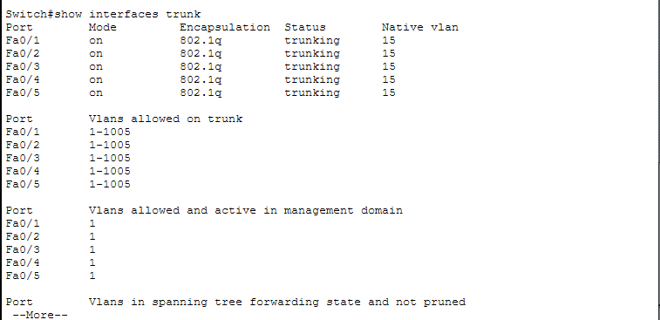

Accessing From PC1 VLAN 10 to PC4 VLAN 10
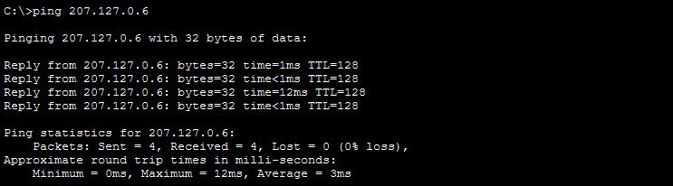
Accessing From PC3 VLAN 5 to Router :
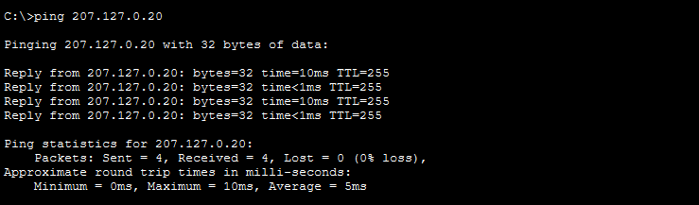

Configuring multiple VLANs for Router to Central switch
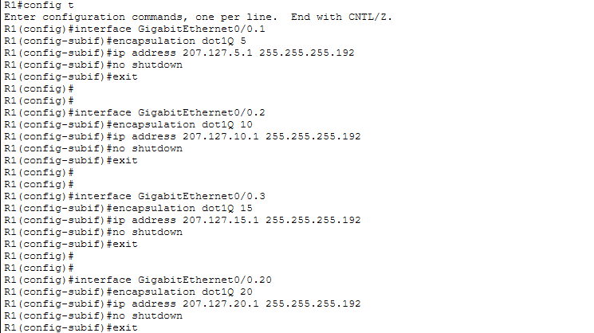

Configuring switch 10 and switch 25 with nonegotiate
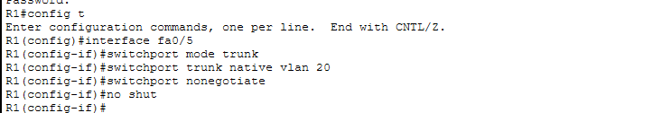

Assing IP with Interface 25 to all switches
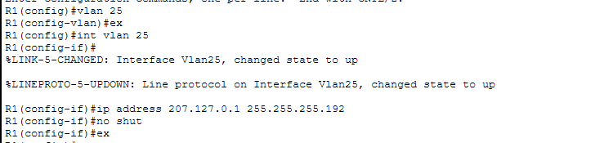
Configuring trunk negotiation is disabled for switch to switch
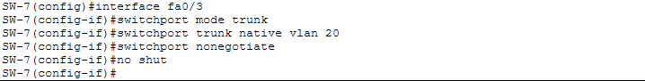
Accessing From Management PC VLAN 25 to all Switches .

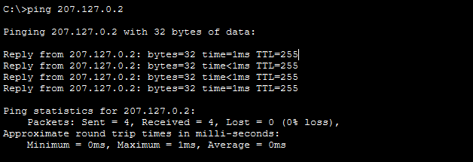
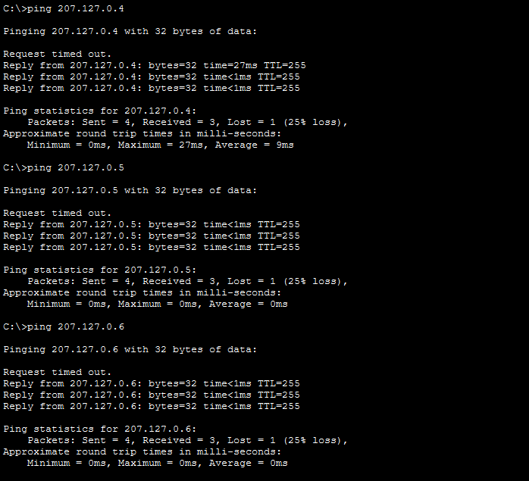

Configuring central switch with interface fa0/6 for the router :
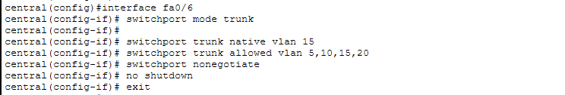

Configuring Router for Management PC :
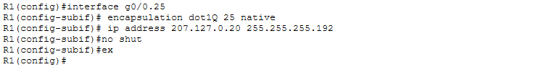

Accessing Router from Management PC with VLAN 25


Applying ACL for router so only management PC Can Access router:
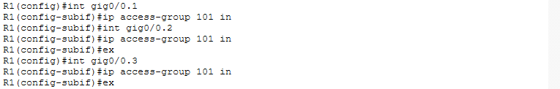

OUTPUT :
Accessing router from Management PC
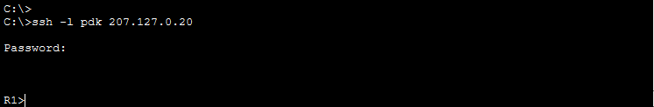

Trying to access from another PC’s

